Conflict of Interest
Specialist Disability Accommodation (SDA)
Easy Read Version

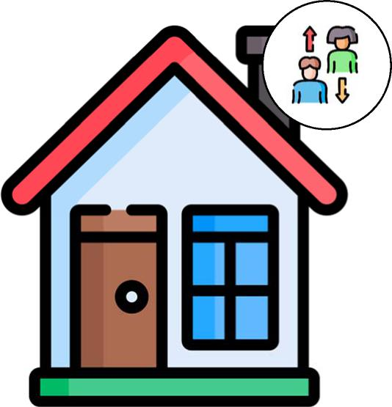

What’s in this document?
What’s in this document? 2
About this document 3
What is a conflict of interest? 4
Examples of a conflict of interest 5
How do we reduce the risk of a conflict of interest? 6
What does my SDA provider need to do? 7
How to make a complaint 10
Who can I ask for help? 11
Contact us 11

About this document
    Bold  Not Bold | This information is written in an easy read way. We use pictures to explain some ideas.  You can ask for help to read this Conflict of Interest Specialist Disability Accommodation (SDA) booklet. A friend, family member or support person may be able to help you.  We have written some important words in bold, which means the letters are thicker and darker.

What is a conflict of interest?
      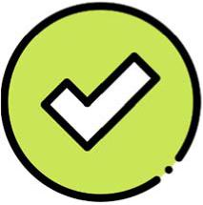    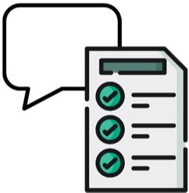 | A conflict of interest is when someone doesn’t do their job properly - because they have interests in something else.  These interests could be personal or organisational.  Personal interests mean that the person, their family or friends will benefit from what they do.  Organisational interests mean that the person’s organisation will benefit from what they do.  We should always do what is best for you.  A conflict of interest may be:  · Actual - it happened  · Potential - it could happen  · Perceived - it seems like a conflict, but is ok if it’s monitored and communicated with you.  It is ok for a support provider to have a conflict of interest, as long as they tell you and have a plan to manage it.

Examples of a conflict of interest
     | A conflict of interest can happen when:  · Your Specialist Disability Accommodation (also known as SDA) provider is also your support provider and doesn’t look after you properly.  · Your SDA provider puts you in a house they own, even if another house might be better for you.  · Your SDA provider uses your confidential information and provides it to another provider or company for money.

How do we reduce the risk of a conflict of interest?
  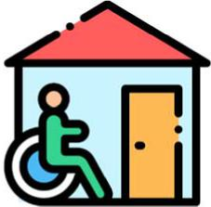   | To reduce the risk of a conflict of interest we make sure the client and their family or guardian understand what support we provide.  This includes our role as a NDIS service provider and accommodation provider.  This is done through:  · our website, brochures and other information  · the intake process  · discussions with the client, family/guardian  · conflict of interest policies  · service agreements  · the consent process

What does my SDA provider need to do?
Your Property Manager will:
 | include you in discussions about how your supported independent living service will be delivered
 | provide you the service quickly while making sure it meets your needs.
 | communicate with you in an open and honest way. This includes telling you if we’re not the right support service for you.
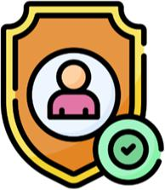 | protect your privacy and confidentiality  your files are kept secure in a locked filing cabinet and on a secure electronic server.
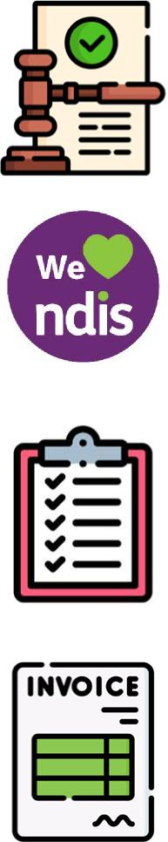 | follow the law –  National Disability Insurance Scheme Act 2013 and Australian Consumer Law.
 | follow the NDIS Code of Conduct and Practice Standards
 | keep accurate records of the supports provided and provide them on request
 | provide invoices of the services delivered
 | help you, your family or guardian contact the NDIA when asked or required
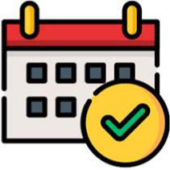 | review your service at least once a year or if something changes
 | support you to move out if you choose to
 | we will write to you, your family or guardian within five business days if something changes in your contract
 | support your right to have choice and control.
 | check to make sure everything is alright with your support
 | listen to your feedback, concerns and complaints and support your decisions  - Poster with Community Advocates  - A Notice for your SDA Provider SDA-16

How to make a complaint
     | If you think there is a conflict of interest you can make a complaint.  Talk to Kyeema first and ask to make a complaint.  If you don’t feel comfortable talking to Kyeema, you can ask an advocacy organisation or someone you trust to help you.

Who can I ask for help?
    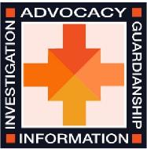 | If you would like help to make a complaint you can call:  Kyeema’s Community Advocates  NDIS Quality and Safeguards Commission  1800 035 544  Office of the Public Advocate  1300 309 337

Contact us
If you have any questions, you can contact Kyeema by:
  @   | Telephone  (03) 5523 5999  Email  admin@kyeema.com.au  Asking a staff member

